Homecoming Parade Guidelines and Entry Forms
www.ohio.edu/homecoming

Homecoming Parade Information
Saturday, October 20, 2018
Parade Start Time: 10:00AM
To incorporate this year’s theme, “Athens State of Mind”

Prizes will be awarded to the first, second, and third place floats and banners. Winners will receive recognition at the football game following the parade.

REGISTRATION INFORMATION:
Submit application online at www.ohio.edu/homecoming.

Parade Entry Description
Describe your entry in the Homecoming Parade and how it supports this year’s theme, “Athens State of Mind”. Consider including names of people, a description of the float/banner, and anything unique about your entry or organization. This information will be used to create a description that will be read as your entry passes by the judges’ table on the Schoonover Patio. The Campus Involvement Center reserves the right to edit the description that will be read.

PARADE DAY INFORMATION
The parade begins at 10:00AM and following with the Ohio University Bobcats football game against Bowling Green State University. It is critical that we have cooperation from all participating members of the parade in order to make the parade run smoothly. The parade WILL take place RAIN OR SHINE! In the event of severe weather, a parade staff member will notify the contact person listed on the entry form via phone.

Check in will start at 8:00AM at West Union Street Office Complex (WUSOC) parking lot. Specific locations and times will be assigned once all entries are received. The contact person will receive an email with the assignment.

The parade officially starts as units turn left onto Union Street (From WUSOC parking lot), continuing up Union Street to turn right on S. Congress. The parade will then make a Left onto President Street before turning left onto Court Street and going up to Washington Street. The parade will turn right onto Washington Street and then right onto College Street. The judges and grandstand will be on the Schoonover patio along College Street. The parade will then turn left onto Union St. and right onto University Terrace. The parade ends at Templeton Blackburn Alumni Memorial Auditorium.

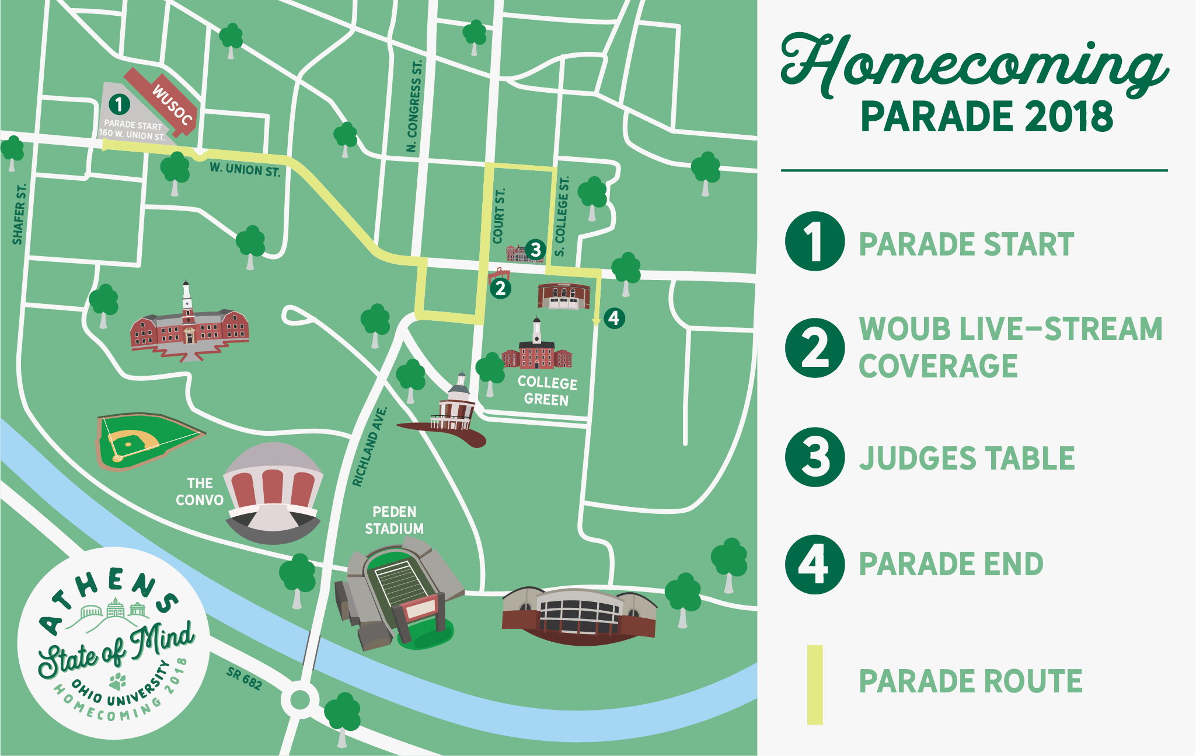

FLOAT & BANNER COMPETITION 2018: INFORMATION AND GUIDELINES

GENERAL COMPETITION INFORMATION
Participants must follow safety requirements set forth by the Ohio University Environmental Health and Safety (EHS) department (requirements below). All floats must be fully constructed by Saturday, October 20, 2018 at 10:00 AM so EHS staff can do a thorough inspection of your float that day. Someone from your group will need to be present at this time to answer questions and provide samples of construction materials. Incomplete floats will not be inspected and will not be eligible for parade participation.

You will need a basic description of the float and how it relates to this year’s theme. There is a section on the entry form for this purpose. Please limit these descriptions to 250 words. Winning floats and banners will be announced during the Homecoming football game at Peden Stadium.

If you would like to opt out of the parade judging competition, please note this on the sign up application.

Campus Involvement Center (CIC) reserves the right to deny any entry based on the description.

Float construction must feature the following dimensions:
- Height – 8.5 feet (above flatbed), Width – 8 feet, and Length – 45 feet.
- All floats must be secured by a strong metal hitch.
- All organizations are required to recycle float materials immediately following the parade.

JUDGING INFORMATION
In order to participate in the parade, every entry must be in the line-up at its designated time. You will receive the time and location information via email to your group’s registered contact person prior to the day of the parade. Any parade entrants who are not in line at the appointed time will not be able to participate. Judges and Campus Involvement Center staff members or volunteers may disqualify any float or banner from participation in the parade at any point before and/or during the parade.

BANNERS
The banner you use for competition should be approximately the size of a twin bed sheet. Materials can include, but are not limited to, paints, glitter, fabric, etc. Banners will be judged based on their incorporation of theme, creativity, overall appearance, and group support. Your group will walk with the banner in the parade. One vehicle is permitted in the parade to accompany the group’s banner entry.

FLOATS
Floats must follow all safety requirements as noted in this packet.
JUDGING CRITERIA: FLOATS AND BANNERS
Parade judges will make final decisions regarding all place distinctions.

Points | Design | Theme | Originality and Spirit
5 | Excellent craftsmanship  Excellent public appeal | Clearly incorporates Homecoming theme | All participants’ dress enhances theme  Clearly promotes organization(s)  Clearly celebrates Ohio University  High level of interaction with parade crowd
4 | Good craftsmanship  Good public appeal | Adequately incorporates Homecoming theme | Most participants’ dress enhances theme  Adequately promotes organization(s)  Adequately celebrates Ohio University  Good interaction with parade crowd
3 | Reasonable craftsmanship  Moderate public appeal | Somewhat incorporates Homecoming theme | Some participants’ dress enhances theme  Somewhat promotes organization(s)  Somewhat celebrates Ohio University  Moderate interaction with parade crowd
2 | Poor craftsmanship  Poor public appeal | Poorly incorporates Homecoming theme | Few participants’ dress enhances theme  Poorly promotes organization(s)  Poorly celebrates Ohio University  Very little interaction with parade crowd
1 | No craftsmanship  No public appeal | Does not incorporate Homecoming theme | No participants’ dress enhances theme  Does not promotes organization(s)  Does not celebrate Ohio University  No interaction with parade crowd
PRIZE MONEY
 | Floats | Banners
1st Place | $500.00 | $250.00
2nd Place | $400.00 | $200.00
3rd Place | $300.00 | $150.00

SAFETY REQUIREMENTS FOR FLOATS AND BANNERS
All participants should be aware general safety and injury prevention methods associated with float construction. The City of Athens has an ordinance prohibiting the use of flammable decorative materials so be sure to follow the rules. In addition, University policy concerning decorative materials, house decorations, and float construction includes:

- During construction, combustible supplies and materials used to construct or decorate floats such as cardboard, paper products, and paints) must be stored away from all heat sources. They should not block fire exits.
  - The construction site should be well lighted for night activities. Please continually check the surrounding area for nails, wood scraps, and lumber with protruding staples, nails, etc. If you are using electric power tools and weather is damp, use a ground fault disrupter receptacle to avoid electric shock or serious injury. These can be purchased at most hardware stores.

- To insure the safety of parade participants and the public, towing vehicles larger than vans, pick-ups, and sport utility vehicles will not be permitted in the parade. If your vehicle is questionable concerning these guidelines, please ask the Campus Involvement Center for approval of the vehicle in the parade.
- Vehicle to float connection; Float safety connection must be a secure process, such matched hitch and ball set up mounted to vehicle frame, pintle hitch mounted to vehicle frame, or a fifth wheel mount set up also mounted to vehicle frame. Safety chains are needed to connect between tow vehicle and float.
- If horses are used to pull the float, make sure that they are under control at all times and you clean up after them. Wagons should not be pulled by “human power” because hills can present special concerns for safety.
- Floats must be structurally sound and safely designed. The main platform must not have holes or hollow areas where someone could fall through.
- All standing people must have something to hold onto (i.e. a railing, pole, handle, etc.) or they must be seated at all times. Railing must be at least 42” height and be able to support 200 pounds of pressure. Must have an access opening to walk in and out without a trip hazard. Opening no less than 24” and stay closed while in the parade.
- Seating must be secured to prevent injury.
- There shall be no exposed nail heads, staples, chicken wire ends, etc. in areas where they will be in contact with people. Use proper nail lengths or bend the ends.
- Select the right materials. Purchase only materials that are flame resistant. Materials such as flame resistant crepe paper, foil, etc. can be purchased. Check the materials to make sure that they have been labeled as flame resistant. Do not use facial tissue-type paper, straw, dry plant materials, or folders.
- If carbon dioxide extinguishers are used for creating smoke, there should be ventilation.
- Good visibility for the driver must be maintained at all times. An adequate unrestricted view should be maintained. Do not obstruct view with smoke.
- Any electrical cords must be properly installed, protected, and in good repair.
- A fire extinguisher must be provided on each float. A fully charged, minimum rating of 10 ABC type fire extinguisher should be purchased specifically for this purpose. Do not remove extinguishers from residence halls or Greek houses.
- No decorations may be placed on lights or around heating and electrical equipment. No open flames such as kerosene lamps or candles are permitted.
- All generators cannot be on floats due to carbon monoxide, heat, electrical, and flammable liquid (fuel)
- Tires on float need to show tread to prevent side slippage on brick streets and must maintain air pressure to carry load.
- Safety blocks for tires must be provided on each float. Scrap wood from float construction should be sufficient. However, make sure the blocks are large enough to hold the float on a significant incline.
- We discourage people from riding inside vehicles that rest underneath a float. If this is done, the design of the float should emphasize protection for anyone who will be riding underneath or on the inside during the parade. This would include:
  - Providing emergency exits – door or windows should be able to open immediately.
  - Ample ventilation for removal of exhaust – exhaust pipes should be in good repair and discharge to the outside of the float.
- Any decorations or debris falling off the floats should be picked up by the organization and not left to litter campus, city or county roads.
- Participants on float must keep extremities inside the railing at all times to prevent possibility of injury
- Alcoholic beverages are not permitted to be on floats

For additional safety information, please contact Environmental Health and Safety at 740-597-1748.

FLOAT DISPOSAL AND RECYCLING

We are proud of Ohio University’s commitment to recycling and community responsibility. Salvageable materials are redistributed throughout the community to non-profit groups for good use.

Following Homecoming weekend, all materials must be thoroughly dismantled and all salvageable materials should be disposed of immediately following the parade. All waste materials must be discarded in proper dumpsters or by other legal methods. Salvageable materials should be stored in a neat manner as to not create a hazard. Groups are required to recycle unwanted materials.

If you have questions regarding recycling, contact the Campus Recycling Office at 593-0231 or email at recycle@ohio.edu.

All groups are required to recycle unwanted materials. Recycling will occur immediately following the parade itself

FLOAT AND BANNER COMPETITION COMPLIANCE AGREEMENT

The rules and guidelines set forth in this registration entry govern the participation of competing groups, commercial entries, political candidates, and other parade entries. By participation in the parade, the entrant acknowledges that the packet has been read and understood.

Your group agrees to comply with all of the rules, regulations, and guidelines concerning the 2018 Homecoming Parade Float and Banner competitions.

I/we understand that disregard for any of the rules and regulations will result in removal from the Homecoming Parade as well as forfeiture of any monetary prize awarded to your organization and any entry fees. I/we, as group representative(s), understand the changes made to this year’s Homecoming Parade rules and I/we agree to abide by these rules.

Our float/banner must be directly related to the “Athens State of Mind” Homecoming theme or we may be disqualified from participating. This disqualification may occur as late as Saturday morning of the parade itself.

This deadline for entering the parade is Monday, October 15, 2018 by 5:00PM. All entries must be submitted online through the Homecoming website: www.ohio.edu/homecoming. I/we understand that if we miss this deadline, we may be prevented from participating in the parade. Late entries will be considered on a case-by-case basis at the sole discretion of the Campus Involvement Center.

I/we understand that University administrators will be inspecting floats on the morning of the parade to determine their relevance to the Homecoming 2018 “Athens State of Mind” theme. If it is determined that our float is not supportive of the Homecoming theme, we may be disqualified and will not be allowed to participate in the parade.

PARADE STAFF CONTACT INFORMATION

Campus Involvement Center
Josh Gruenke
Associate Director of Student Activities
gruenke@ohio.edu
740-593-1761

