UCC Programs Committee Agenda
September 12, 2023
PROGRAM CHANGES
- College of Arts & Sciences
Program Code: MA4221
Program Name: Economics
Department/School: Economics
Contact: Roberto Duncan (duncanr1@ohio.edu)
Desired Start Date: Fall 2024

We propose a change from a stand-alone to a dual-listed program with no change in the number of credit hours for the program. As a result, we need to set up our MA courses as 5000-level courses (rather than the 6000-level courses that we currently have) to allow for dual listings. Our MA program is a one-year long program. Students take courses in the fall and spring semesters and complete a master's paper in the summer. We modified some existing 6000-level courses by changing the course numbers to 5000-level courses, which we have been advised do not require a program change proposal. However, some of the 6000- level courses in the program will be replaced by 5000-level courses that are new to the MA program. In this program change proposal, we highlight these proposed changes. To be clear, the proposed changes involve the four dual-listed courses in the fall semester: ECON 3000/5000, ECON 3030/5030, ECON 3040/5040, and ECON 4870/5870. These are new to the program and will replace the existing four 6000-level courses: ECON 6003, ECON 6030, ECON 6040, and ECON 6350. There is no change in credit hours.

All Current Program Requirements | Proposed Program Requirements |  | Comments
Semester 1--Fall  ECON 6003 Mathematical Economics and Economic Statistics (4)  ECON 6030 Advanced Microeconomic Theory I (4) ECON 6040 Advanced Macroeconomic Theory (4) ECON 6350 Econometrics I (4) | Semester 1--Fall  ECON5000 Mathematics for  Economists (4)  ECON 5030 Intermediate Microeconomics (4)  ECON 5040 Intermediate Macroeconomics (4)  ECON 5870 Econometrics (4) | Is this a new course?  Y  Y  Y  Y | We are replacing the existing 6000-level courses in the program with 5000-level courses that are new to the program.
Semester 2--Spring  ECON 6031 Advanced Microeconomic Theory II (4) ECON 6041 Advanced Macroeconomic Theory II (4) ECON 6380 Applied Econometrics (4)  Elective 5000-level or above (4) | Semester 2--Spring  ECON 5031 Advanced Microeconomics (4)  ECON 5041 Advanced Macroeconomics (4)  ECON 5880 Applied Econometrics (4)  Elective 5000-level or above (4) | N  N  N  N | For the three courses other than the elective course, we modified the existing 6000- level courses in the program to create the respective 5000-level courses for them (for which we have been advised that a program change proposal is not needed).
Semester 3--Summer  ECON 6950 or ECON 6960 Master’s Thesis or Master’s Paper (4)  In summary, a minimum of 36 credit hours is required to complete the program (28 credit hours for core courses + 4 credit hours for an economics/math elective + 4 credit hours for the master’s paper). | Semester 3--Summer  ECON 6950 or ECON 6960 Master’s Thesis or Master’s Paper (4)  In summary, a minimum of 36 credit hours is required to complete the program (28 credit hours for core courses + 4 credit hours for an economics/math elective + 4 credit hours for the master’s paper). | N | No modifications

NEW PROGRAM/CERTIFICATE
- College of Health Sciences & Professions
Program Code: DN1235
Program Name: Doctor of Nursing Practice
Department/School: Nursing
Contact: Margie Vogt (vogtm@ohio.edu), Sherleena Buchman (buchmans@ohio.edu)
Desired Start Date: Fall 2024

The School of Nursing (SON) is collaborating with OhioHealth to initiate a Nurse Anesthetist (NA) program track. The NA program will be a new program track in the BSN-to-DNP program. NA students are required to complete a Doctor of Nursing Practice (DNP) as an entry-to-practice requirement, are required to enter a full-time year-round program of study including 103 credit hours (47 credit hours in the DNP core and 56 in the specialty area) and 2300 faculty-supervised, clinical hours.

Students in the BSN-to-DNP/NA program track will complete the DNP core courses, complete a scholarly project and the specialty focused clinical courses. This is consistent with other BSN-to-DNP program tracks including Family Nurse Practitioner (FNP) program track, the Adult-Gerontology Acute Care (AGACNP) program track, the Psychiatric Mental Health (PMHNP) program track, the Nurse Leader (NL) program track and the Nurse Leader-Nurse Educator (NL/NE) program track. This new program track would require 53 specialty focused credit hours in addition to the 47 credit hours in the DNP core courses.

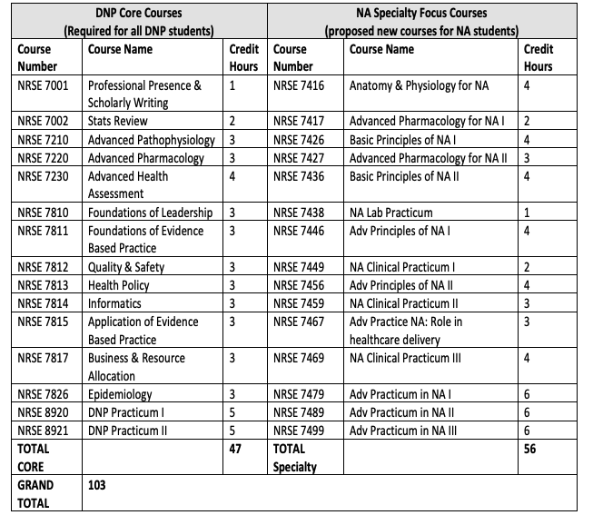
- Scripps College of Communication
Program Code: ORXX24
Program Name: Photojournalism Minor
Department/School: School of Visual Communication
Contact: Stan Alost (alost@ohio.edu)
Desired Start Date: Fall 2024

This proposed minor will provide students, particularly in related fields, with the foundational knowledge and basic storytelling skills to create visual communication messages rooted in journalistic standards using both still photography as well as audio and video. The minor can be accomplished in 15 credit hours. It is anticipated that there will be demand for the minor from students in other programs including Journalism, Sports Administration, Media Arts and Studies, and Communication Studies.

Required core: 12 hours
• VICO 1421 or 2521 Introduction to Visual Communication Skills: Photography; 3 hrs (prerq for 1421 includes minor code)
• VICO 2390 Photojournalism I: Single images; 3 hrs (prereq is 1421, will accept 2521)
• VICO 2392 Photojournalism II: Picture Story; 3 hrs (prereq is 2390)
• VICO 3310 Multimedia Production for Visual Communication; 3 hrs

Electives: select one; 3 hours
• VICO 3320 Photojournalism III: Motion and Sound (prereq 3310); 3hrs
• VICO 3921 Synthesis Storytelling for Visual Communication; variable hours (no prereqs)
• VICO 4321 Documentary and Essay Photojournalism; 3 hrs (added minor as prereq)

The minor requires a minimum of 15 credit hours. Because VICO 3921 has variable credit hours, a student could complete the minor with up to 18 credit hours.

EXPEDITED
- College of Arts & Sciences
Program Code: BS2109
Program Name: Environmental Science & Sustainability
Department/School: Environmental & Plant Biology
Contact: Nancy Manring (manring@ohio.edu)
Desired Start Date: Spring 2023

When the ESS major was entered into OCEAN, the information we provided indicated that to fulfill the Experiential Learning requirement, students need to register for at least 2 credit hours from the list of course options we provided (refer to “Sample 4-year program” document attached under the Relations Tab in OCEAN). When our program information was entered into the Undergraduate Catalogue and the DARS, there was a mistake. The catalogue and the DARS say students need to take ONE course from the listed options with variable credit hours listed as 1-x credit hours, depending on the course. We need the DARS and catalogue corrected to say, “Students need to choose one of the following courses (2-credit hours minimum).”

- University College
Program Code: BDXX02
Program Name: Bachelor of Data Analytics
Department/School: University College
Contact: David Nguyen (nguyend4@ohio.edu)
Desired Start Date: Spring 2024

As the Bachelor of Data Analytics (BDA) program has started preparing documentation for the degree program to move through the approval process at the state level, we have learned that there is a preference for changing the degree program name to a new naming convention – Bachelor of Science with the program name as Data Analytics (BSDA). There are no changes to the curriculum.

NOTIFICATIONS
- Patton College of Education
Program Code:BS6307
Program Name: Integrated Mathematics
Department/School: Teacher Education
Contact: Matt Felton (felton@ohio.edu)
Desired Start Date: Spring 2024

A clarification came in after the approval of BS6307 at the last UCC meeting in spring 2023. The correct entry for the program change is listed on the Discussion tab.

The correct entry for the program change for Spring 2023 should be to replace
OLD REQUIREMENT:
Complete 9 hours of math electives from the following options:
MATH 3000 History of Mathematics (3cr)
MATH 3060 Introduction to Mathematical Reasoning, Problem Solving, and Proof (3cr)
Any courses above MATH 33000 (3300)
NEW REQUIREMENT:
1. Complete 3 hours of math electives from the following options:
MATH 3000 History of Mathematics (3cr)
MATH 3060 Introduction to Mathematical Reasoning, Problem Solving, and Proof (3cr)
Any courses above MATH 3300
2. Complete one of the following courses CS/Data courses
MATH 2530 Introductory Data Science (4cr)
CS 1400 Fundamentals of Computing (3cr)
3. Choose one of the following K-8 Math courses:
MATH 1101 Elementary Topics in Mathematics I (4cr)
MATH 1102 Elementary Topics in Mathematics II (4cr)
MATH 2110 Introductory Geometry for Middle School Teachers (3cr)
MATH 2120 Number and Algebra for Middle School Teachers (3cr)

