Annual Report

Executive Summary

March 2021 – March 2022

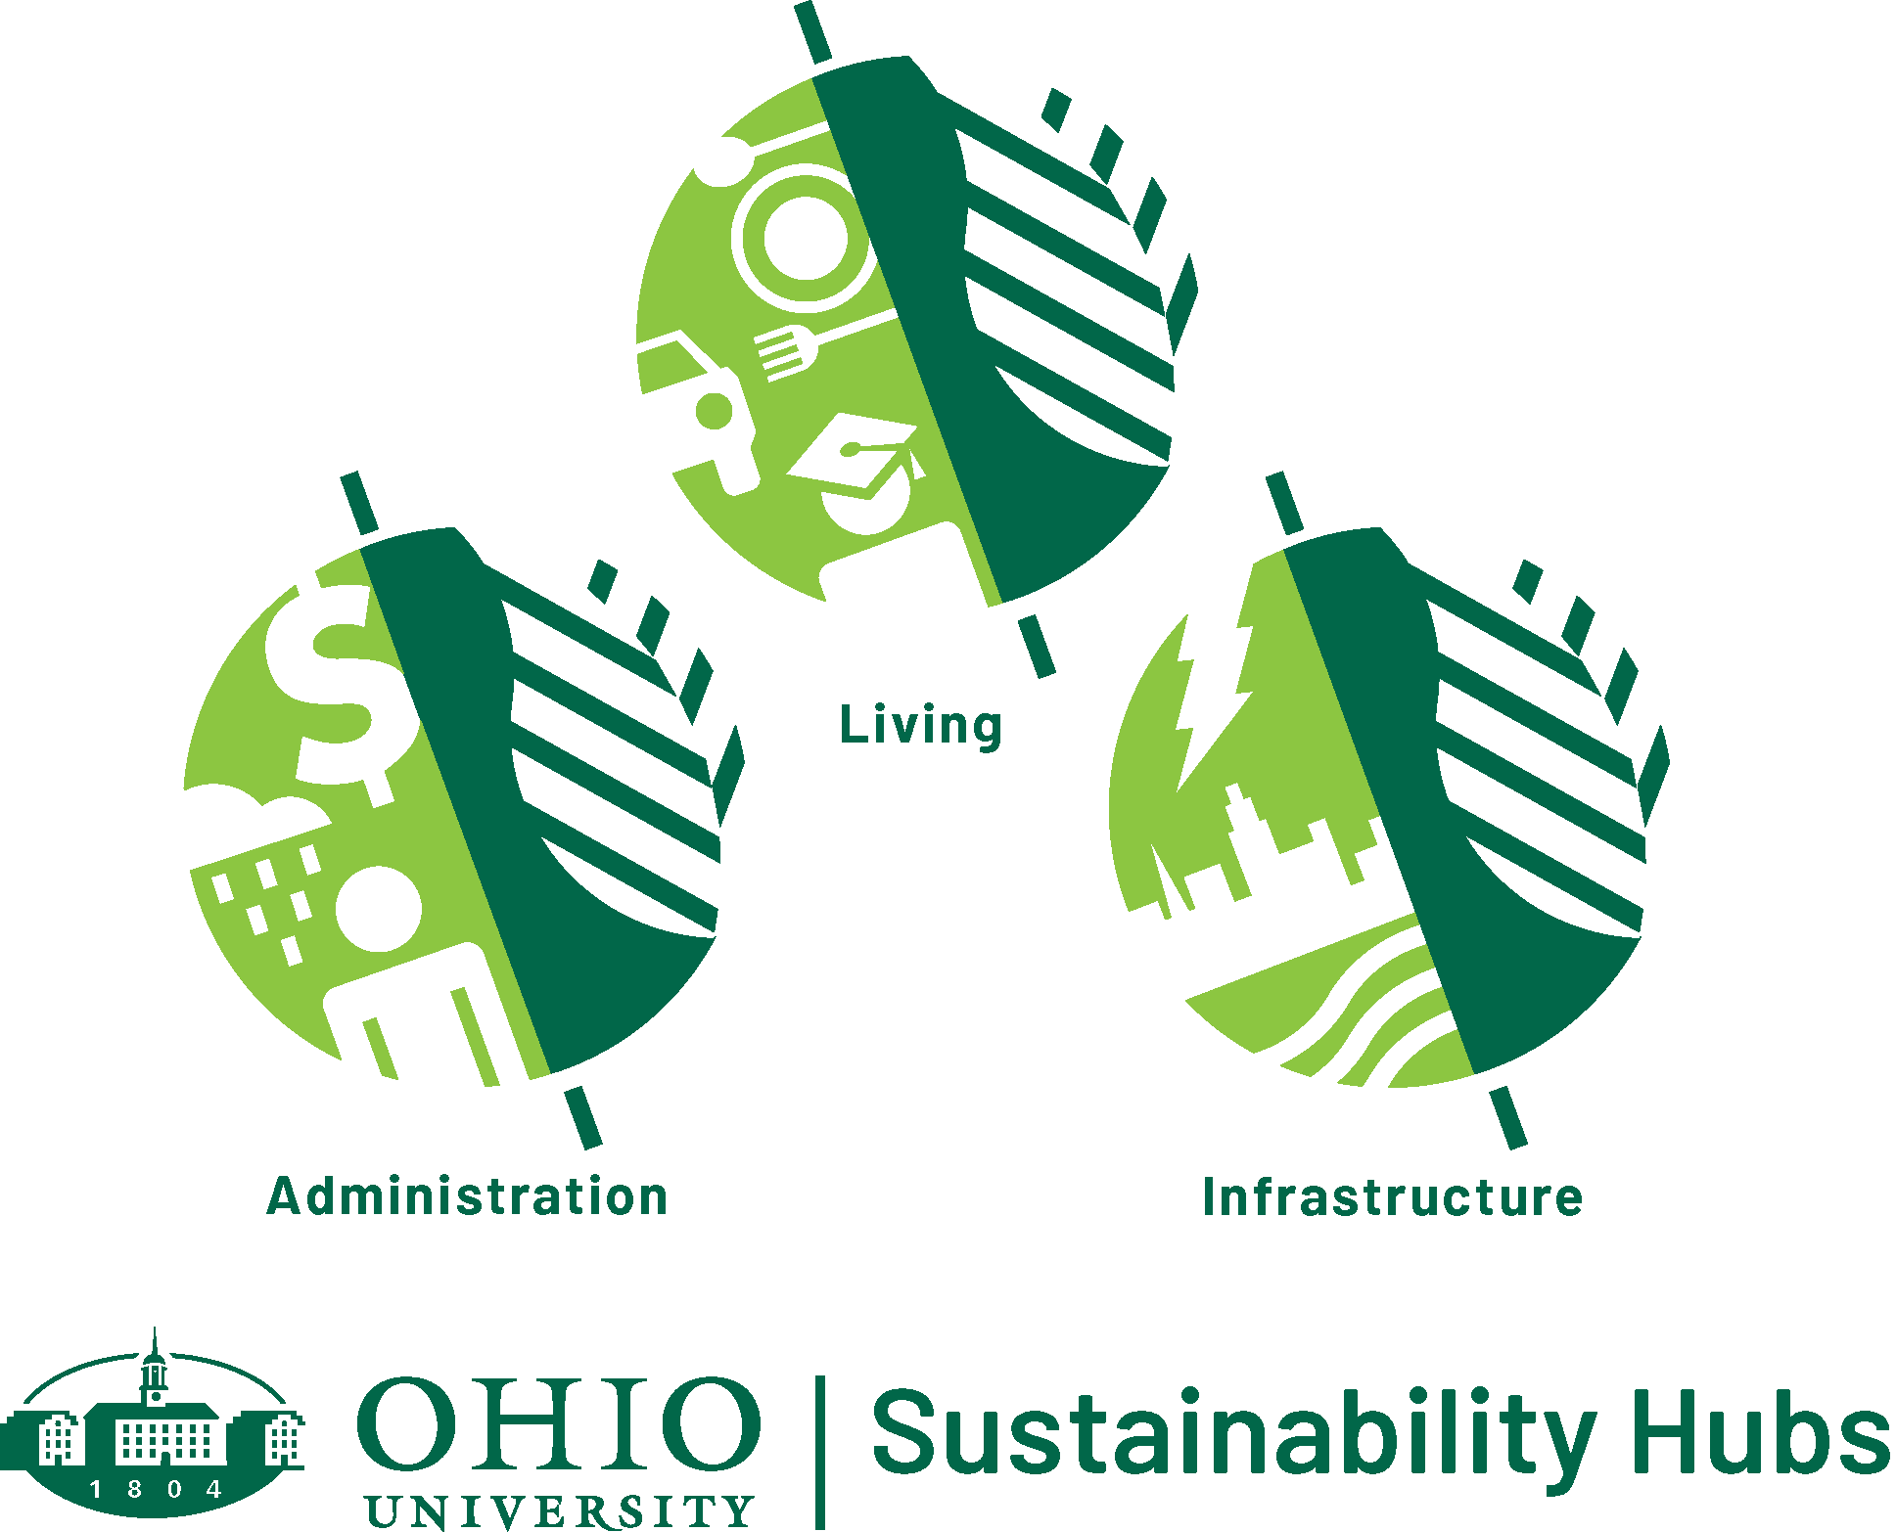

Introduction

After three years in existence, the Sustainability Hubs have reached maturity. Hub seminars occur routinely and are well-attended; organizational documents and procedures are in place; goals have been established and initiatives are well underway. The focus of the Hub annual reporting will now shift to progress on Sustainability & Climate Action Plan goals, metrics, targets and initiatives.

Please continue reading the brief highlights for each Sustainability Hub in this executive summary. Links are provided to theme areas for each Hub – these links contain detailed information for each theme, including goals, metrics, proposed, current and completed initiatives, media mentions, and more.

Sustainability Hub Highlights

Sustainable Administration Hub - Climate, Human Resources, Investments and Procurement themes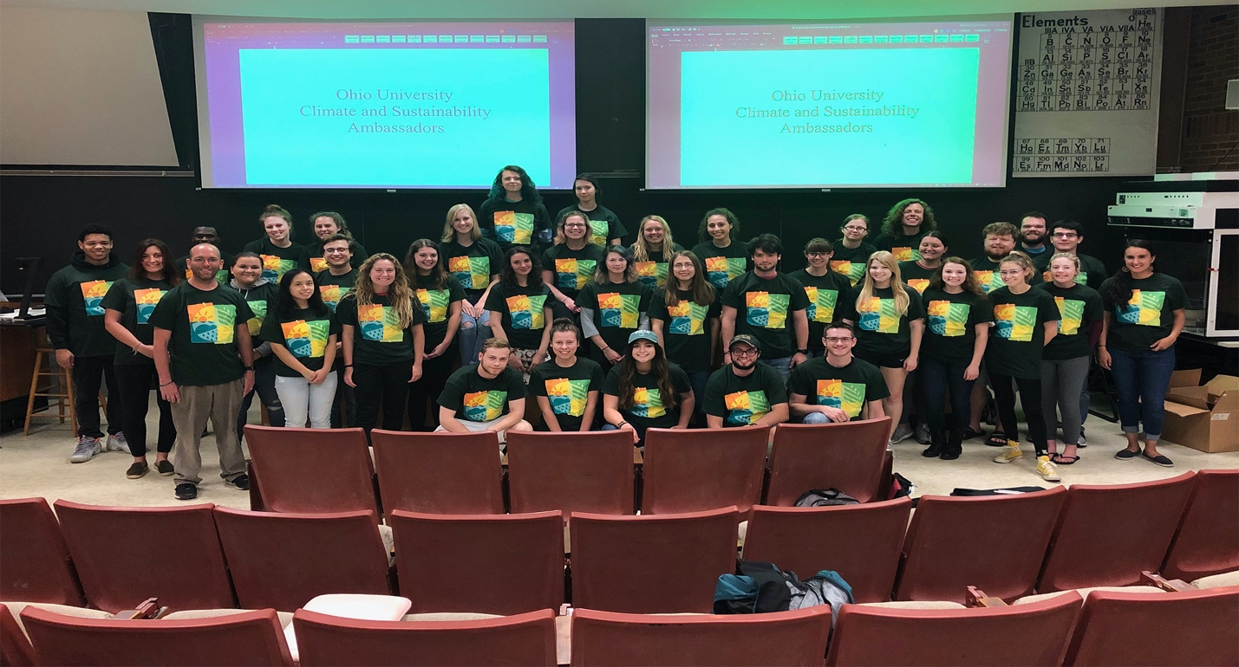

Climate –
  - In Fall 2021, Hub coordinator Dr. Ryan Fogt, along with Director of Sustainability and Energy Management, Elaine Goetz, and two Ohio University Student Trustees, Ellen Gill-Franks and Sarah Ladipo, gave a hub seminar on climate action and Ohio Universities climate priorities.​
  - The Climate & Sustainability Ambassadors made virtual visits to elementary school classrooms in April 2021 and published 4 podcast episodes on the theme of climate in April 2021.​
  - 100% of Ohio University’s energy now comes from renewable energy certificates (RECs)​

Human Resources -
  - Significant changes to the University FlexWork policies were established during the remote work of the pandemic. Many other trainings for staff and leaders were offered and expanded in AY 2020—2021.
  - WellWorks offered new virtual platforms for wellbeing (with a new website ohio.edu/wellness), including the launch of the Ohio Wellness Pilot Program. The campus achieved platinum level in the Healthy Business Council of Ohio ratings for the second year in a row.
  - The Office of Diversity and Inclusions launched a Core Trainings Webpage, an Inclusive Excellence Strategic Plan, a Make Respect Visible Campaign, and conduced a campus climate for diversity survey

Investments -
  - The Spring 2021 Sustainable Administration Hub seminar focused on the University’s sustainable investment strategies
  - The Office of Sustainability is working on improving connections with university administrators who oversee other aspects of the investment portfolio relative to the goals in the Sustainability and Climate Action Plan.

Procurement –
  - New procurement contracts in energy and waste were signed in 2021. Pouring rights contracts will be signed in 2022.
  - Model sustainability-centric RFP criteria were added to the RFP template and sustainable purchasing guidelines were updated (such as recycled content, local products, conflict free minerals, biodegradable, etc.)

Sustainable Living Hub - Food, Grounds, Student Life and Transportation themes
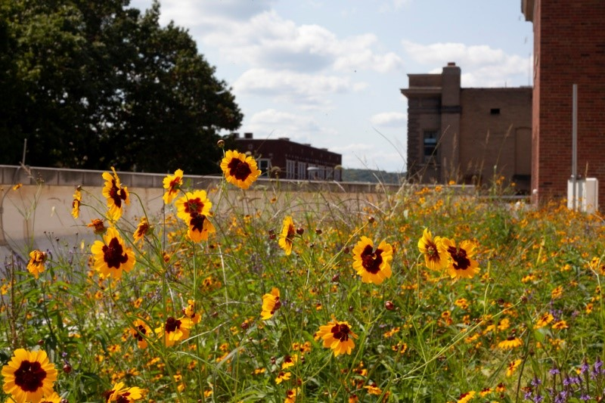
In 2021, the Sustainable Living Hub promoted its themes of Food, Grounds, Student Life, and Transportation through the following activities:

- Food -
  - In Fall 2021, the Living Hub organized an event to harvest vegetables from the Baker Garden, compost plant waste and prepare the beds for overwintering.
  - The Hub also recruited volunteers to plant seedlings for a Community Food Initiatives give-away and promoted the Discovery Kitchens events for students.
  - The Fall 2021 seminar featured a panel of experts in sustainable food production from OHIO and the community which was attended by 132 people.

- Grounds -
  - In Spring 2021, the Living Hub assisted in the development of educational signage on native plants and animals at the Outdoor Museum, and installed bat houses at the Ridges and on the Schoonover Green Roof.
  - In Fall 2021, the Living Hub organized an invasive species removal from the Phase 1 East Rain Garden in coordination with Susan Calhoun and contributed to our acceptance as an affiliate of the Bee Campus USA.
- Student Life -
  - The Living Hub continued supporting two student organizations: the Green Initiative, a group that promotes green infrastructure on campus and the Plant Club, a group that has been involved in campus and community conservation activities.
  - A new relationship with the Environmental Affairs Commissioner of the Student Senate was established.
  - The Living Hub has also engaged undergraduate and graduate students in science research, engineering or communications projects and outreach, many of which are featured on our growing website.

- Transportation -
  - The Living Hub held a seminar in Spring 2021, attended by 49 individuals, to educate students and faculty about impacts of transportation on climate change and opportunities to use alternative transportation on campus and in the community with guest speaker, Tia Hysell.

Sustainable Infrastructure Hub - Buildings, Energy, Waste and Water themes
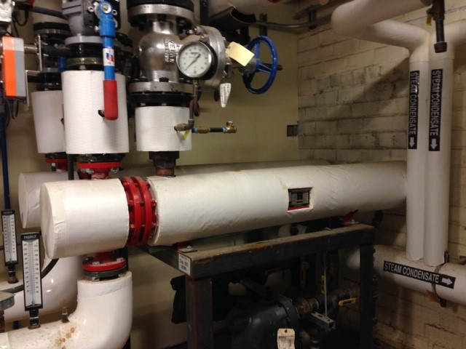
In 2021, the Sustainable Infrastructure Hub promoted its themes of Water, Waste, Energy, and Buildings through the following activities:

- Waste -
  - In spring, 2021, the infrastructure hub held a virtual seminar on sustainable waste management showcasing the research of Dr. Andrew Weems on recycling plastics through 3D printing. This seminar can be viewed from the Sustainable Waste Management theme website.

- Water -
  - The infrastructure hub held another virtual seminar in fall, 2021 on sustainable water practices related to agriculture and nutrient pollution in partnership with Applied Environmental Solutions. This seminar can be viewed from the Water theme website.
- Energy -
  - Through 2021, infrastructure hub coordinator Dr. Pagan has been involved in pursuing a project that would bring a large solar array to the area, potentially allowing OHIO to meet renewable energy goals. More information will be found on the Energy theme website if and when a contract is signed.
  - FMS has started an Energy Management group to collaborate on building energy efficiency, which has focused heavily on meter maintenance this year.

- Buildings -
  - The infrastructure hub has been working behind the scenes to help establish a physical location for the Sustainability Project Laboratory. This endeavor remains underway as we move into the new year.
  - Please see the Buildings theme website for the Design & Construction/Zero Waste/Habitat for Humanity pilot salvage program.

Executive Summary and Website Contributors

Elaine Goetz, PhD
Director of Energy Management & Sustainability, Office of Sustainability

Sam Crowl
Associate Director, Office of Sustainability

Jesus Pagan, PhD
Sustainable Infrastructure Hub Coordinator
Associate Professor of Engineering Technology & Management, Russ College of Engineering

Ryan Fogt, PhD
Sustainable Administration Hub Coordinator
Associate Professor of Meteorology, College of Arts and Sciences
Director, Scalia Laboratory for Atmospheric Analysis

Kim Thompson, PhD
Sustainable Living Hub Coordinator
Associate Professor of Instruction in Environmental and Plant Biology, College of Arts and Sciences

Madeline Yeatts
Sustainable Infrastructure Hub Graduate Assistant, Office of Sustainability
Voinovich School of Leadership and Public Affairs, MSES

Chukwuma Smart Amaefula
Sustainable Administration Hub Graduate Assistant, Office of Sustainability
Voinovich School of Leadership and Public Affairs, MSES

Steel Brooks
Sustainable Living Hub Graduate Assistant, Office of Sustainability
Scripps College of Communication, MA, Photojournalism

Xander Stultz
Reporting Assistant, Office of Sustainability
College of Arts and Sciences, BS. Urban Planning and Sustainability

Elena Delach
Sustainable Project Laboratory Coordinator
College of Arts and Sciences, BS Biological Sciences

