Registering TOUCH hours – new users

To register your TOUCH hours, you will need to create an account with the Track it forward system. These instructions are for students who are registering with the system for the first time. You do not need to create an account every year, your credentials should last until you graduate.

- Navigate to the Track it forward website here: https://www.trackitforward.com/group/aacom-touch-site
- Once on the AACOM page, navigate to and click on the OU-HCOM campus you attend
  - Please be mindful of selecting YOUR correct campus – Athens, Dublin or Cleveland (our campuses are about halfway down the page)
  - 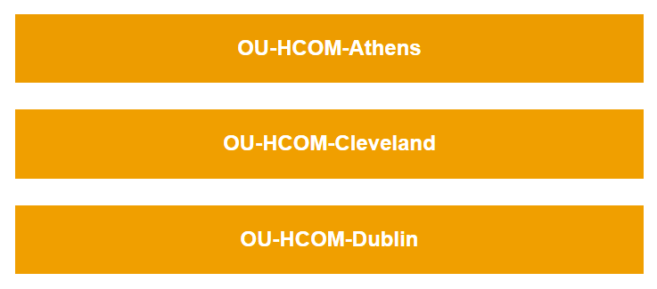
- Click “Sign up” and enter your personal information
- Please use your OU email address when registering
- Once the portal opens, you can enter TOUCH hours for encounters you have completed

Registering TOUCH hours – continuing students
If you already have an account, follow these instructions to register your TOUCH hours. All hours must be submitted within 30 days of completing the service activity. Please recall, if you are in a leadership position for an organization, your time working on service projects for that organization do not qualify for TOUCH hours.
- Navigate to the Track it forward website here: https://www.trackitforward.com/site/ou-hcom-cleveland
  - Please be aware, this is for Cleveland campus students ONLY. Athens and Dublin students will need to follow the site to their campus specific website.
- You should see “log hours” at the top left hand of the screen as shown below.
  - 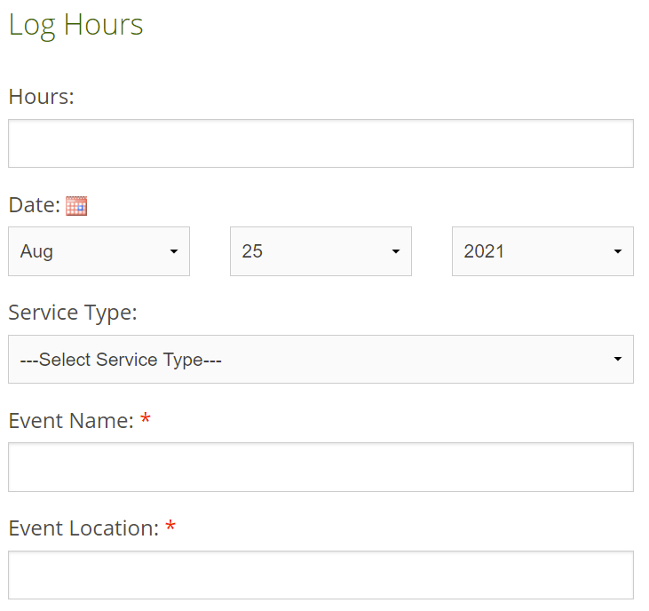
- Complete the following sections for approval:
  - Hours
  - Date
  - Service type
    - TOUCH – any volunteer activity that works to improve the health and wellness of a community which incorporates osteopathic tenets, awareness, principles, and practice. If you need more information on what qualifies as TOUCH, please refer to the AACOM webpage here: https://www.aacom.org/become-a-doctor/resources-for-medical-students/cosgp/touch-program/touch-program-rules-and-regulations
    - Volunteer – any volunteer activity that does not qualify for TOUCH will automatically be considered general volunteer hours. These do not count toward the TOUCH hours recognition levels (silver, gold, platinum), but still look good on your residency application! If you’re ever unsure if your volunteer work counts as TOUCH, contact the Director of Community Outreach at your campus.
  - Event name
  - Event location
  - Event country
  - Event setting
  - Event coordinator name
  - Event coordinator email
  - What type of service was provided?
  - How does this event serve to benefit the community?
  - Notes
    - Only complete this section if you need to provide any specific details regarding your experience which will help the TOUCH coordinator confirm or deny if your service counts for TOUCH or not.
- Once the form is complete with the mentioned sections, click the orange “Submit Time” button at the bottom
- The SGA Student Director of Community Outreach or appointed committee member will review hours and approve/deny in accordance to AACOM standards. Your hours will not be officially registered until they are confirmed.

